Test techniques assignment 1

Equivalence class and boundary value testing

A bus company has special rules for price calculation, when hiring a bus incl. chauffeur for a one-day trip. The total price consists of an initial fee plus a kilometer fee. These fees are given below for a standard bus:

* There is an initial fee of 2500 kr.
* The price depends on the distance as follows:
  + Anything below 100 km. costs 10 kr. per km.
  + For kilometers between 100 and 500 km the price is 8 kr. per km.
  + For kilometers above 500, each kilometer costs 6 kr. per km.
  + Negative distances are considered invalid.

Customers can choose between three different types of buses:

1. Standard bus (max. 50 passengers)
2. Luxury bus (max. 60 passengers and better equipped)
3. Mini bus (max. 25 passengers)

The initial fee is multiplied by 1.3 for a luxury bus and by 0.8 for a mini bus. The kilometer fees are multiplied by 1.5 for a luxury bus and by 0.6 for a mini bus.

A mockup of the user interface for price calculation is shown below:

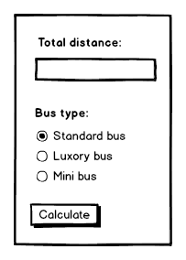

The following GitHub repository contains a solution that solves the problem mentioned above.

<https://github.com/henrikkyhl/Test-techniques-assignment-1>

The solution contains business logic and couple of unit tests, but no user interface. The GitHub repository also contains a spreadsheet, named “*Test techniques assignment 1.xlsx*” that you should use when you answer the questions below.

## Questions

1. Identify equivalence classes and boundary values. Use the traditional approach for equivalence class testing (i.e. single fault assumption where invalid values are included). For boundary value testing you should follow the ISTQB approach and include invalid values.
2. Derive test cases and fill out the attached spreadsheet.
3. Modify the unit test class in the attached solution (i.e. the GitHub repository mentioned above) so that all the test cases are covered.
4. Create *SpecFlow* tests that cover all the testcases.